DAY 28 REPORT
TASK 1 - Figure out the difference between Matplotlib graphs and Power BI graphs

OBJECTIVE
The objective of this task is to understand data visualization using Matplotlib (Python library) and compare it with Power BI (Business Intelligence tool). The task involves creating different types of graphs such as bar chart, line chart, and pie chart to analyze student performance data.

DATA VISUALIZATION CHARTS USED
In this task, the following charts were created using Matplotlib:

1. BAR CHART – Average Marks by Subject
Purpose:
To analyze the average performance of students in each subject.
Insight:
• Helps identify strongest and weakest subjects
• Shows subject-wise performance comparison
Code Used:
plt.figure(figsize=(10,5))
subjects = df.columns[1:8]
avg_marks = df[subjects].mean()
plt.bar(avg_marks.index, avg_marks.values)
plt.title("Average Marks by Subject")
plt.xlabel("Subjects")
plt.ylabel("Average Marks")
plt.xticks(rotation=45)
plt.show()
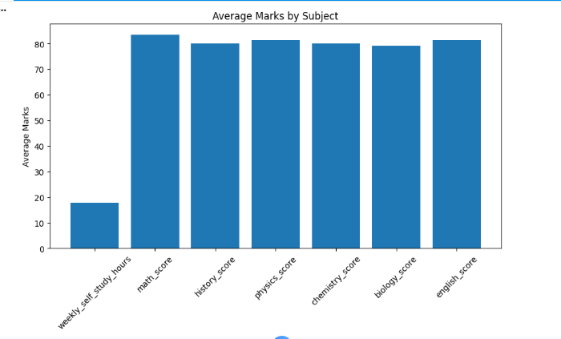

2. LINE CHART – Gender-wise Average Marks
Purpose:
To analyze performance difference between male and female students.
Insight:
• Helps compare academic performance by gender
• Shows trend difference between groups
Code Used:
plt.figure(figsize=(6,4))
gender_avg = df.groupby('Gender')['Total_Marks'].mean()
plt.plot(gender_avg.index, gender_avg.values, marker='o', color='purple')
plt.title("Gender-wise Average Marks")
plt.xlabel("Gender")
plt.ylabel("Average Total Marks")
plt.show()
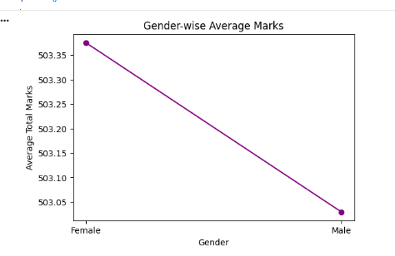

3. PIE CHART – Grade Distribution
Purpose:
To analyze how students are distributed across different grades.
Insight:
• Shows percentage of each grade category
• Helps understand overall class performance
Code Used:
grade_counts = df['Grade'].value_counts()
plt.figure(figsize=(6,6))
plt.pie(grade_counts, labels=grade_counts.index, autopct='%1.1f%%')
plt.title("Grade Distribution")
plt.show()
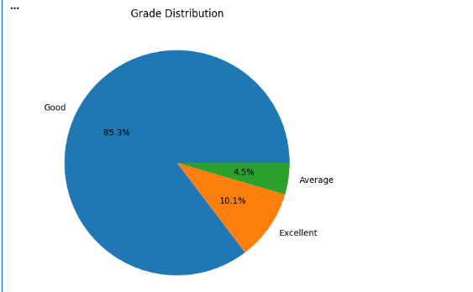

Difference Observed in This Task
In Matplotlib, Bar Chart, Line Chart, and Pie Chart were created using Python code. These graphs displayed the required information but remained static after generation.
In Power BI, the same data was visualized through an interactive dashboard. A filter was applied to the Low Study category, and all visualizations automatically updated to show only the data related to Low Study students.
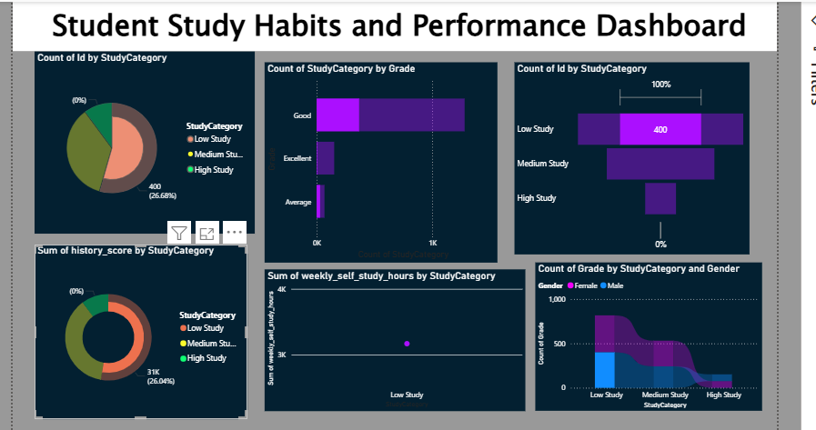

Similarity Between Matplotlib and Power BI Graphs:
Although Matplotlib and Power BI use different approaches to create visualizations, the information presented by the graphs remains the same when the same dataset is used.
Example: Pie Chart – Grade Distribution
- In Matplotlib, a pie chart was created using Python code to show the distribution of student grades.
- In Power BI, a pie chart was created using the Grade field and Count of Grade.
- Both charts displayed the same grade distribution and percentages.
- The difference is that the Matplotlib pie chart is static, whereas the Power BI pie chart is interactive and can respond to filters and slicers.

(powerbi piechart)
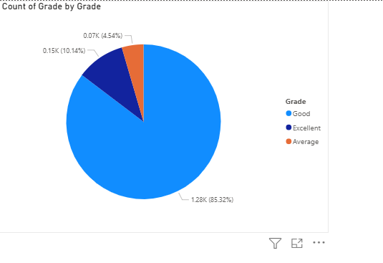
(matplotlib piechart)

CONCLUSION:
In this task, Bar Chart, Line Chart, and Pie Chart were created using Matplotlib and compared with Power BI visualizations. Both tools provided the same insights from the student performance dataset. However, Matplotlib produced static graphs using Python code, while Power BI provided interactive dashboards with filtering capabilities. Overall, Matplotlib is useful for coding-based data analysis, whereas Power BI is more suitable for interactive reporting and visualization.

